Community Update
April 2019

Kopit Lodge intends to be transparent in its dealings and report to the community. With this in mind, Kopit Lodge submits the latest updates:

Kopit Lodge strives to establish good working relationships with other organizations in pursuit of its mandate to “Protect the Water.”

- Community Meeting Update
- Kopit Lodge will be hosting a community update at the Elsipogtog Community Hall. There will be updates given on the two shared decision-making models that were chosen as the best options at our last community update.
Bo Augustine along with lawyer Bruce McIvor and Angela Decembrini will be hosting the meeting and taking any questions or concerns you may have about this into consideration. We want to hear what you have to say! Please come and join us on May 21st from 4:30pm to 7:00PM at the Elsipogtog Community Hall.

Lunch will be served. Door prizes will be given out throughout the evening.

- Negotiation Table
- On March 14, 2019, Elsipogtog met with Canada in Moncton to continue preliminary discussions about their interests in New Brunswick. A further meeting by teleconference was held on March 28, 2019. Elsipogtog and Canada are looking for an inclusive and effective process to discuss issues of importance to the Mi’kmaq in general and Elsipogtog specifically.

- Energy Efficiency Efforts
- Kopit Lodge is going to be taking part in a Direct Install – Community Outreach Program for Elsipogtog in partner with NB Power.

NB Power's Community Outreach Program will help with saving money and becoming more comfortable with low-cost, energy-efficient products.

ENERGY EFFICIENCY KITS INCLUDE:
- LED light bulbs
- Water-efficient showerheads
- Faucet aerators
- Water heater pipe wrap

Within the next few months, there will be people going around the community coming into homes and installing the energy efficiency kits. Our goal is to hit every house and apartment to lower our energy footprint here in Elsipogtog, but if you decide you do not want to take part or have any questions about this project you can email: imw.legalfund@gmail.com, call 338-0125, 521-0803 or come by to Kopit Lodge at 33 Riverside Dr.

- New Hire
- Welcoming Christian Augustine to the Kopit Lodge team. Christian is our new administrative assistant; he is working closely with Kenneth and Bo on our Table discussions with Canada.

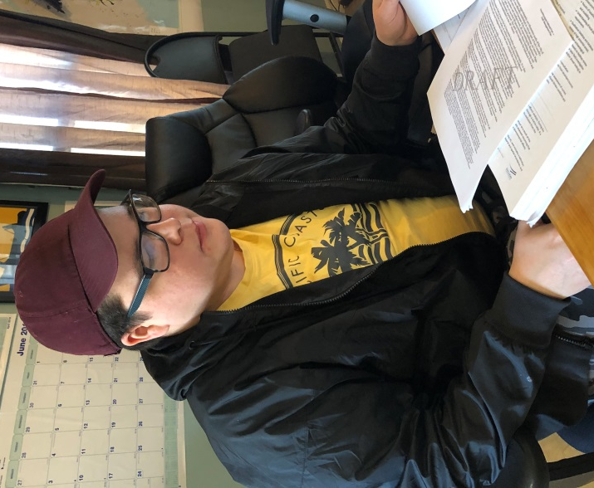

- Chase the Ace
- Chase the Ace is our main fundraiser for the Legal Action fund for our Aboriginal Title Claim to protect the water. This time around we partnered with the Elsipogtog Fire Department. The Jackpot is at $5000+ Tickets are available all week at the sports bar for $5 a color and $20 for all 4 colors. CTA happens every Sunday from 2-5PM at the Elsipogtog Community Hall, e transfers are accepted at elsipogtogchasetheace@hotmail.com and you do not have to be present to win. Live stream of the draw is posted on Kopit Lodge’s Facebook page. You can also win one of the new sponsored cards.

Community Meeting
May 21, 2019
Elsipogtog Community Hall
4:30pm – 7 pm

The purpose of the community meeting scheduled for May 21, 2019, is to provide Elsipogtog members with an update on the work of the exploratory table to date.

We would also like to have a second discussion about the issues to be addressed as part of the table and the community's vision for the outcome of these discussions.

These are very important issues that affect all Elsipogtog members, and we anticipate that additional community meetings will be required to refine the vision and develop a strategy as we move forward with the exploratory discussions.

Door prizes of gift cards from the River of Fire Market will be drawn throughout the evening.

A meal will also be served

Come on down, we would like to hear your ideas and visions on how you feel Elsipogtog can move forward.

All our allies are welcome to attend

